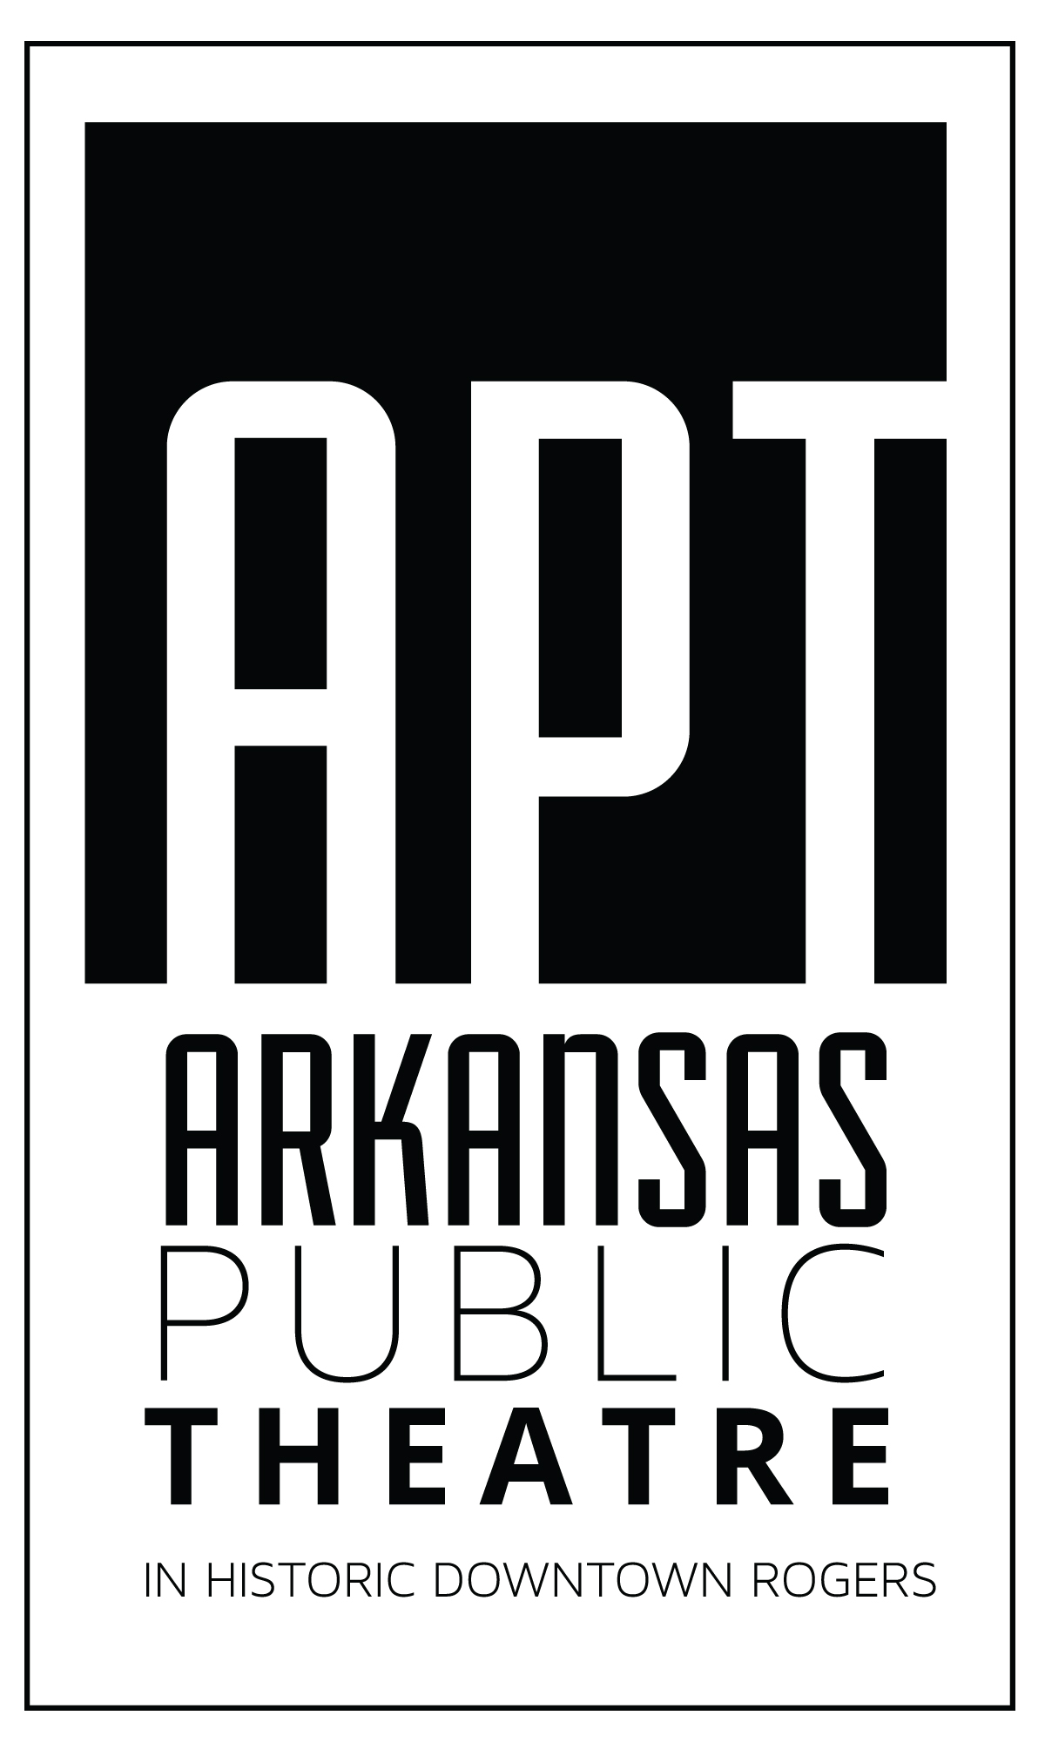

POLICIES AND PROCEDURES
FOR
PRODUCTION CAST AND CREW
(March 3, 2022)

TABLE OF CONTENTS

GENERAL ARKANSAS PUBLIC THEATRE INFORMATION 2
SOCIAL MEDIA POLICY 2
REHEARSAL SPACE AUDITORIUM and DRESSING/GREEN ROOMS 3
COMP TICKETS/MEETING GUEST AFTER THE SHOW 3
TECH WEEK (SUNDAY BEFORE OPENING) 3
DECORUM BACKSTAGE, GREENROOM AND DRESSING ROOM 4
HEALTH AND SAFETY 4
SET CONSTRUCTION………………………………………………………………………………………………………….………5
ITEMS TO WHICH CAST AGREED AT AUDITIONS 5
TECHNICAL CREW……………………………………………………………………………………………………………………..5
COSTUMES 6
WIGS/HAIR AND MAKE-UP 7

GENERAL ARKANSAS PUBLIC THEATRE INFORMATION

Tickets are on sale now! Please share official social media with your friends and family. Like us and follow us.

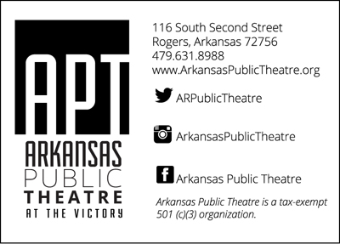

SOCIAL MEDIA POLICY

The images of productions are the property of APT. Toward that end, APT zealously protects what images and when the images are broadcast in any medium.

Cast and crew agree:
A. No video images of any APT play rehearsal or performance may be taken to be broadcast in any form other than within private cast/crew groups to be used for rehearsal purposes (this excludes any private groups created on Facebook or Instagram; example, a video of a dance rehearsal);
B. Still images of any APT play rehearsal may be taken up to but not including the Sunday prior to the show opening (see TECH WEEK) and may be posted in any medium;
C. No still images of any APT performance may be taken, that is, production photos taken from the front of the stage of a performance;
D. Backstage or other “non-stage” still images may be taken and posted at any time;
E. Cast and crew will be provided images prior to opening night which include the cast marquee photos and production photos featuring every cast member to be used on any social media as soon as the images are provided; and,
F. Cast and crew are encouraged to retweet @ARPublicTheatre; tag on Instagram @arkansaspublictheatre #APTSeason36 & #TitleOfProduction; and “like” APT Facebook page as a method of promoting their production.

REHEARSAL SPACE AUDITORIUM and DRESSING ROOMS/GREEN ROOMS

Items left overnight in the theater (including dishes and scripts) may not be here when you return. Shoes, rehearsal materials can be left in the dressing rooms (not on the floor, use your bin downstairs).

If you make a mess, clean it up.

Please notify the director if the restrooms are out of toilet paper.

Stay hydrated! Keep a reusable water bottle labeled with your name on it. We provide Culligan Water downstairs in the green room. There is a water fountain located next to the men's restroom on the first floor.

Hot water access and coffee maker are available downstairs in the green room.

Cleaning staff will have no regard to your belongings including costumes and props. Please hang all costumes and return props to their appropriate homes.

COMP TICKETS/MEETING GUEST AFTER THE SHOW

Please welcome your guests attending a performance to meet you OUTSIDE IN FRONT OF THE THEATER after the show once you are out of costume. APT operates with a majority volunteer staff and we need to respect their time to allow clean up after the show.

Your tickets will be under YOUR name. If you are using another cast or crew member’s tickets, the tickets are under the cast or crew member’s name that gave them to you to use. APT Staff no longer will be responsible for cast tickets other than checking people in.

Allowed amounts of PREVIEW NIGHT guests is at the discretion of the house manager and you will be notified a week prior to the preview night. Please inform you guest to check in using your name, no outside food or drink, no photos/videos.

Cast shall change into street clothes and have microphones removed and placed in the assigned space. In any event, cast and crew shall vacate the facility NOT LATER than 30 minutes after the performance unless, otherwise approved.

No guests shall be allowed backstage or in the dressing areas. Tours of backstage may be allowed if approved by the APT Manager and production stage manager. Guests may be allowed on stage after a performance if prior approval is obtained by the APT Manager and production stage manager.

For musicals, the production is not completed and no action on stage shall be taken, unless and until the “exit music” is completed.

TECH WEEK (SUNDAY BEFORE OPENING NIGHT)

Please check in using the sign in sheet when arriving for the scheduled performance beginning the week of the show. Please use the South stage door.

Actors will be required to remain backstage during rehearsal beginning tech week.

Parking for actors beginning tech week is available in the municipal lot on Walnut Street, between 2nd and 3rd Streets and also the municipal lot on Elm Street, between 2nd and 3rd Streets.

DECORUM BACKSTAGE, GREENROOM AND DRESSING ROOM ETIQUETTE

APT is an open, welcoming organization. We embrace diversity and encourage everyone to be themselves. We will not tolerate the use of inappropriate language or comments that would make anyone involved in the production uncomfortable. Please be aware of your audience. In the case of children cast in the show, you will be recused of your role/position if you use profanity in the presence of young actors. We will not tolerate you laying hands on another.

Please use your time before your performance to disconnect from your life and focus on your character. Be respectful of your fellow actors.

Personal hygiene (see COSTUMES).

All cell phones must be stored in your personal bins during tech week rehearsals. You may use the same or any communication device in the green room/dressing room area only to listen and only with headphones.

Makeup mirrors are prone to heat. Do not place items in front of them or leave them on for long periods of time.

HEALTH AND SAFETY

Your good health is vital to a successful production. Please be conscious of your call times and refrain from any activities that would prohibit you from wasting everything you've worked on.

We utilize Actor’s Equity—the professional union of performers—rules with regard to the following:

A. No alcohol or drug use eight (8) hours prior to any scheduled performance or rehearsal (if you are taking medication prescribe by your health care provider, please confer with the APT designated health care professional to determine application of this to you);

B. You are expected to be rested and fully able to perform for all scheduled performances; and,

C. Breaks will be given during rehearsals as required and modified for Arkansas Public Theatre, 5-minute break every 60 minutes of rehearsal or 10-minute break every 80-120 minutes of rehearsal.

The basement is prone to flooding. Nothing left on the floor.

Rehearsal is closed except for approved guests from the director. Just ask.

For our safety, the front doors of the Victory will be locked 5 min after the stated time of rehearsal. If your call time is later than the stated time of rehearsal, make arrangements with the director to enter the building. For shows with children, the South Stage Door will be used.

Directors will provide contact numbers through Group Me. You will need your phone to have this free app.

Have your friends and family volunteer! They get to see the show for free (providing we have available seats.)

No eating in costume.

Costumes do not leave the theater, including costume pieces that you own.

Please check your props and use the stage prior to the House opening. 7pm on show nights and 1pm on Sunday matinees.

Wifi password for cast only: rltr0ck$

Cast parties are not permitted on Saturday nights due to Sunday call time.

SET CONSTRUCTION

Do not use Powered Saws and/or Power Lifting Equipment without approval from the Director, Technical Director, or AD/SM.

Before the end of every Set Construction and Painting days, the facility must be just as clean and organized as it was before starting, or even more so.

Please return all equipment, tools, and supplies back to proper storage area after use.

ITEMS TO WHICH CAST AGREED AT AUDITIONS

RESPONSIBILITIES IF YOU ARE CAST

- Prior to being cast, you will be asked to review the REHEARSAL SCHEDULE. You will be asked to circle ALL dates for which you have a conflict. THIS INCLUDES DATES FOR SET CONSTRUCTION. As a community theater production, you will be expected to attend AT LEAST TWO of the dates designated for SET CONSTRUCTION.

- You will be required to attend all rehearsals for which you have indicated you do not have a conflict. You will be required to be on time for rehearsals and to be prepared to rehearse with the appropriate equipment (pencils, shoes, etc.).

- Everyone in the cast is REQUIRED to attend and remain at SET STRIKE on the final performance until dismissed. This is estimated to be until 7:00 pm.

- You will adhere to the REHEARSAL SCHEDULE with regard to lines being due.

- You will adhere to the decisions of the PRODUCTION TEAM with regard to how you are styled and how you look in this show.

- While APT is a community theater, its productions have achieved a level of professionalism which the patrons have come to expect. Therefore, we will all work to fulfill this expectation.

- I understand I may be required to supply my own dance shoes, shoes, dance belts, leotards, undergarments, Spanx and/or other costume pieces for the production.

- Women will be required to supply their own AND WEAR Spanx leotard (or similar garment to be determined by production staff) under their costumes; Men will be required to supply their own AND WEAR black compression shorts and a white compression t-shirt under their costumes.

- You will not be allowed to miss any rehearsals for which you have not indicated a conflict REGARDLESS OF things that “come up at the last minute” or your determination that you are “too sick to attend.” We will cast dedicated understudies and replace you if this occurs.

- You are required to have fun by being in the most professional amateur production possible.

TECHNICAL CREW

Unless specified by Director or Stage Manager, all members of the TECHNICAL CREW are to report to their designated crew area not later than 30 minutes prior to performance.

Unless specified by Director or Stage Manager, all members of the TECHNICAL CREW shall access the facility via the front doors.

Unless specified by Director or Stage Manager, all members of the TECHNICAL CREW shall not congregate in the lobby or other areas of the facility other than the work area of the technician.

Unless specified by Director or Stage Manager, all members of the TECHNICAL CREW shall not access the backstage area and shall not access the backstage and in no event shall access the backstage area from the front of the house.

COSTUMES
Proper undergarments are necessary.
Women: nude spanx (the leotard-style) and dance tights will make costumes lay flatter and will help with quick changes. Mic packs can be attached inside the back side of the spanx, keeping it close to your body so mic problems are less likely.

Men: black compression shorts and white compression shirts are required. Mic packs will be attached inside the back of the compression shorts to keep them firmly in place to avoid mic issues during the show.

Shoes: all performers in musicals will be required to provide his/her own shoes. Typically, the shoes will either be black slip-on jazz boots or black/tan character shoes. (Occasionally other types of shoes may be required, such as tap shoes, etc.)

Straight plays: shoes will be decided upon on a case by case basis. We try our best to work with shoes actors already own, but occasionally have to source new shoes to fit with the character/costume plot.

Showering and using proper deodorant is necessary. We don't have the luxury of dry-cleaning all our costumes between each show, so we expect our actors to do everything they can to keep the costumes as clean as possible. The costumer can provide a costume spray that will not damage the costumes if they start to smell less-than-fresh between runs.

No eating in costumes, unless approved by Director/AD/SM/Costumer. Very often we will have snacks backstage. We encourage our actors to enjoy those BEFORE getting into costume. Avoid sodas and colored juices as well.

All costume maintenance will be done by the costumer, unless he/she has given approval for you to undergo the maintenance yourself. (Loose buttons, hooks, etc. may be sewn back on by the actor.) Alterations and anything that changes the integrity of the garment will need to be approved/executed by the costumer. If something happens to your costume, tell the costumer immediately, even if it is Sunday and there is a 3-day break before the next show. Make sure the information is either posted in the GROUPME or texted to the costumer.

Wire hangers are NOT allowed backstage during a show. They inevitably fall and clang and are disruptive to the production. Keep them in the dressing rooms. Hooks will be provided upstairs for quick changes.

Once your costume is approved, it is to be worn that way for every show. The Director/Costumer have worked together to come up with a very specific look for every costume that appears onstage and don't want to see any surprises show up in a performance.

Let your costumer know of any quick changes you have in the show. They may not always be apparent from the script. S/he will find ways to use Velcro/snaps/etc. to make the change easier but will need to know in advance.

Costumes should always be handled with care and hung up properly after every show. Rental costumes will be checked in properly safety-pinned to their hangers, with all tags affixed appropriately. All pieces must be present before the actor is released.

WIGS/HAIR AND MAKE-UP

As included on the audition sheet, within reason, all cast members will be considered for cutting, coloring, perming and other styling as requested by the director and in alignment with the production's creative vision.

All cast will refrain from cutting, coloring, perming, or permanent styling to their real hair during the production time until final decisions are made on styling by the director.

Cast members will want to obtain a small amount of bobby pins for use in the show. There will also be additional bobby pins with the hair/wig stylist.

Cast members will be provided pictures, make-up sketches, diagrams and instructions for make-up applications.

Initially, the make-up artist will oversee the initial make-up applications. Once shown, cast members will be highly encouraged to perform the make-up applications themselves.

Initially, the hair/wig stylist will oversee the initial hair/wig styling. Once shown, cast members will be highly encouraged to perform the hair/wig styling or setting on their own.

If the production requires wigs for characters cast will be required to obtain a wig cap (can be produced from a nylon stocking or purchased for approximately $1.99 @ Sally's beauty supply). If unable to obtain, cast members will make known to wig/hair stylist.

Cast members will be provided make-up and make-up accessories to keep for future productions. Accessories and make-up especially eye cosmetics will not be shared due to health concerns.

Cast members will be provided with hair products and hair accessories according to their character's wig and make-up plot line.

Cast will need to obtain make-up wipes or make-up remover. As theater resources permit, make-up wipes can be distributed on an as needed or emergency case.

Cast will not roll, curl, wash, spray, or use hot tools on any wigs. Wigs will be kept on Styrofoam wig heads with wig pins provided. Wigs will be stored on shelves away from mirror lamps and heating elements.

Due to fire risks, no smoking, flames, or pyrotechnics while wearing a wig.

Make-up supplies are donated to the theater and will always be given in good stewardship and respect for the theater's sponsors.

Cast members will not operate make-up machines such as a professional airbrush machine without full consent from make-up stylist.

Please be aware if you have an allergy to certain hair products or make-up please make the makeup/wig/hair stylist aware. On occasion we also use products that contain latex. If you have a latex allergy, please let the director or make-up/wig/hair stylist know.

All wig, hair and make-up tools belonging to the theater will be used with care and responsibility. Tools provided by the theater will not be allowed to be taken from the theater.

All wigs are property of the theater and will not be taken from the theater by cast members.

Cast members will make known to makeup and hair/wig stylist of needed make-up supplies and accessories they are in need of obtaining.

Although the makeup and hair/wig designer have some creative freedom it is ultimately the director's decision on the creative styling of looks for the production.

Once determined by the director, all styling decisions are final until the production's conclusion. Please do not change, modify, or otherwise adjust any final styling decision without prior consent from director.

